**DAILY ONLINE ACTIVITIES SUMMARY**

|  |  |  |  |  |  |  |  |
| --- | --- | --- | --- | --- | --- | --- | --- |
| **Date:** | **21/06/2020** | | | | **Name:** | **Sheetal** | |
| **Sem & Sec** | **8 B** | | | | **USN:** | **4AL16CS091** | |
| **Online Test Summary** | | | | | | | |
| **Subject** | | **-** | | | | | |
| **Max. Marks** | | **-** | | **Score** | | **-** | |
| **Certification Course Summary** | | | | | | | |
| **Course** | **Hadoop: Master your Big Data** | | | | | | |
| **Certificate Provider** | | | **Great learning** | **Duration** | | | **3 hr** |
| **Coding Challenges** | | | | | | | |
| **Problem Statement:**   1. Program to reverse an array | | | | | | | |
| **Status:completed** | | | | | | | |
| **Uploaded the report in Github** | | | | **Yes** | | | |
| **If yes Repository name** | | | | [alvas-education-foundation](https://github.com/alvas-education-foundation)/ **[sheetal-shettigar](https://github.com/alvas-education-foundation/sheetal-shettigar)** | | | |
| **Uploaded the report in slack** | | | | **Yes** | | | |

ONLINE TEST

CERTIFICATION

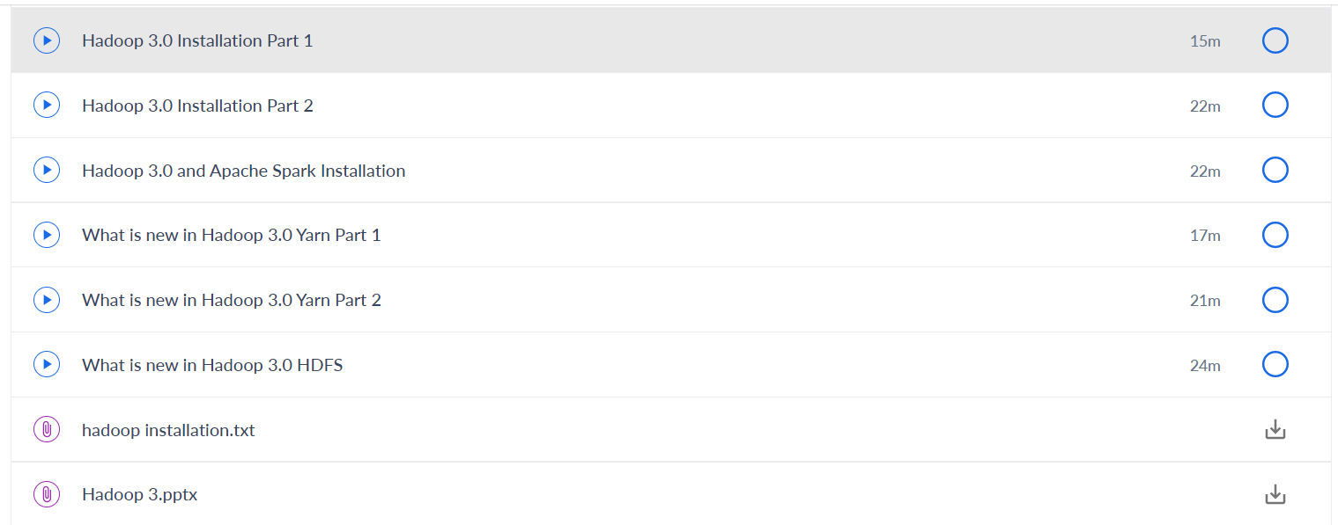

CODING CHALLENGE:

PROGRAM 1 :

1)

defreverseList(A,start,end):

whilestart<end:

A[start],A[end]=A[end],A[start]

start+=1

end-=1

A=[1,2,3,4,5,6]

print(A)

reverseList(A,0,5)

print("Reversedlistis")

print(A)